Personal- My Profile
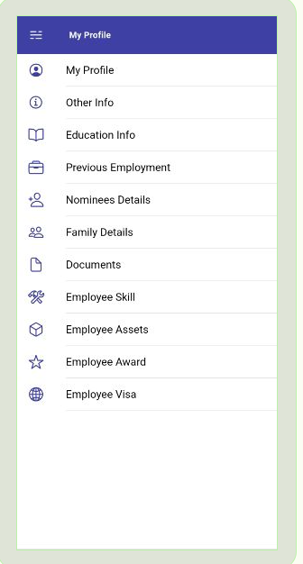

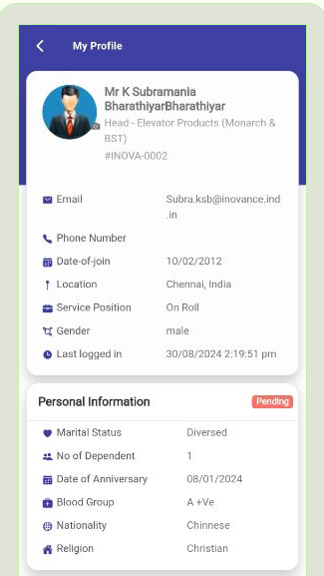

Personal- Other Info
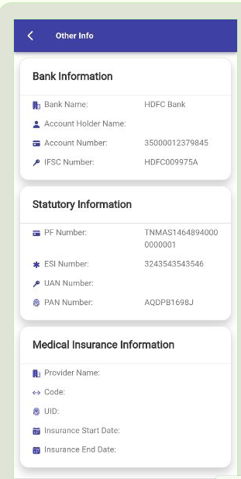

Personal Education Info

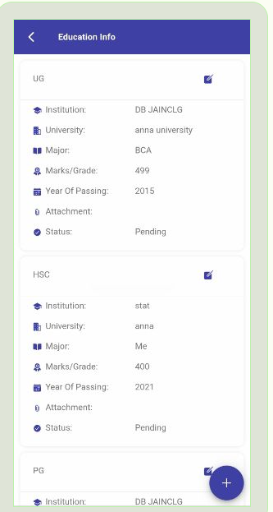

While Create Record
https://web3essapi.elitehrms.in/api/Personal/postEducationDetails
{"EducationDetails":[{"EducationGUID":"14562d64-ca7e-42ee-1f35-410a65fdd414","RequestGUID":"16a93d92-7989-288d-3df7-b19e945134c1","NameOftheDegreeid":"9791","NameOftheInstitution":"sKP","NameOftheUniversity":"anna university","Major":"it","Marks":89,"YearofPassing":2006,"Attachment":"782efdef-d9ca-48b0-be83-444dfb5a6f72","Statusid":"","NameOfthedegree":"","RequestStatus":""}],"Screenid":442}

{
"Response": {
"_status": "Failed",
"_code": "999",
"_Source": "postEducationDetails",
"_Description": "Exception Occured",
"_Details": "Conversion failed when converting from a character string to uniqueidentifier.",
"_TransID": null,
"_Timestamp": "20240830144731"
},
"ScreenID": 0,
"EducationDetails": []
}

While Edit or Update
https://web3essapi.elitehrms.in/api/Personal/postEducationDetails
{"EducationDetails":[{"EducationGUID":"e475e99a-d153-35a8-d40f-35fd358b1618","RequestGUID":"4852365c-b8f0-068b-0835-888d92cb16c0","NameOftheDegreeid":"9789","NameOftheInstitution":"DB JAINCLG","NameOftheUniversity":"ANNA","Major":"msc","Marks":"489","YearofPassing":"2016","Attachment":"b92934cb-2609-461e-82ff-79b420eded2c","Statusid":"6862","NameOfthedegree":"PG","RequestStatus":"Pending"}],"Screenid":442}

{
"Response": {
"_status": "Failed",
"_code": "999",
"_Source": "postEducationDetails",
"_Description": "Exception Occured",
"_Details": "Conversion failed when converting from a character string to unique identifier.",
"_TransID": null,
"_Timestamp": "20240830145102"
},
"ScreenID": 0,
"EducationDetails": []
}

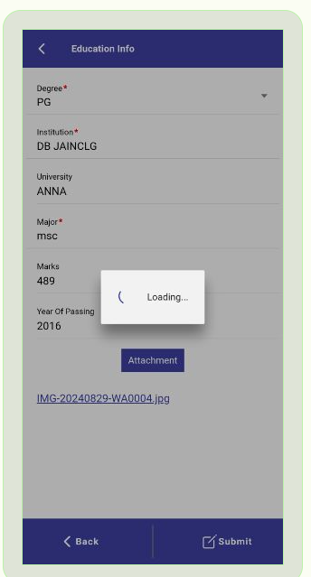

Personal Previous Employment Details

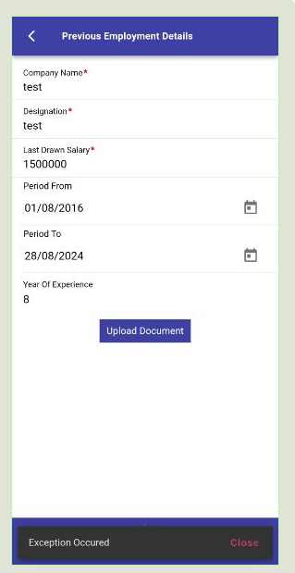
While Create Record
https://web3essapi.elitehrms.in/api/Personal/postPreviousEmploymentDetails
{"PreviousEmploymentDetails":[{"RequestGUID":"1eeced30-51e5-42df-185a-994655b028a7","PreEmpGUID":"4394e835-4867-cf61-cf74-4fb160c21b64","CompanyName":"test","Designation":"test","LastDrawnSalary":1500000,"YearOfExperience":8,"UploadDocument":"","PeriodFrom":"2016-08-01","PeriodTo":"2024-08-28","Status":null,"RequestStatusID":""}],"Screenid":442}

{
"Response": {
"_status": "Failed",
"_code": "999",
"_Source": "postPreviousEmploymentDetails",
"_Description": "Exception Occured",
"_Details": "Conversion failed when converting from a character string to uniqueidentifier.",
"_TransID": null,
"_Timestamp": "20240830145428"
},
"ScreenID": 0,
"PreviousEmploymentDetails": []
}
Step : 2
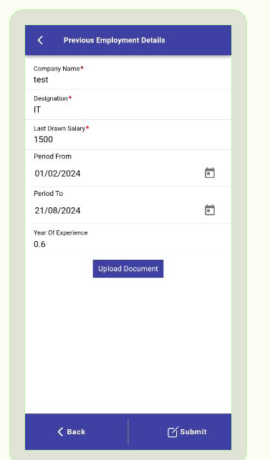

https://web3essapi.elitehrms.in/api/Personal/postPreviousEmploymentDetails

{"PreviousEmploymentDetails":[{"RequestGUID":"f2edabc4-d7be-efb4-b60f-7ab61519b4d6","PreEmpGUID":"e0f77bab-be97-037a-4af5-93d7be1ab868","CompanyName":"test","Designation":"IT","LastDrawnSalary":1500,"YearOfExperience":0.6,"UploadDocument":"","PeriodFrom":"2024-02-01","PeriodTo":"2024-08-21","Status":null,"RequestStatusID":""}],"Screenid":442}

{
"Response": {
"_status": "Failed",
"_code": "999",
"_Source": "postPreviousEmploymentDetails",
"_Description": "Exception Occured",
"_Details": "Error converting data type nvarchar to int.",
"_TransID": null,
"_Timestamp": "20240830152134"
},
"ScreenID": 0,
"PreviousEmploymentDetails": []
}

Edit or Update

https://web3essapi.elitehrms.in/api/Personal/postPreviousEmploymentDetails
{"PreviousEmploymentDetails":[{"PreEmpGUID":"d80db6bd-0976-9fdd-8aaa-d6592d35d06f","EmployeeID":250,"PreviousEmploymentID":"1011","RequestGUID":"0fa7abc8-0c99-2674-f34f-d6f0957c0799","CompanyName":"New one","Designation":"Manager","LastDrawnSalary":100,"YearOfExperience":0.7,"UploadDocument":"","PeriodFrom":"2024-01-01","PeriodTo":"2024-08-31","RequestStatusID":"6863","RequestStatus":"Finalized"}],"Screenid":442}

{
"Response": {
"_status": "Failed",
"_code": "999",
"_Source": "postPreviousEmploymentDetails",
"_Description": "Exception Occured",
"_Details": "Error converting data type nvarchar to int.",
"_TransID": null,
"_Timestamp": "20240830152534"
},
"ScreenID": 0,
"PreviousEmploymentDetails": []
}

My Profile Family Details
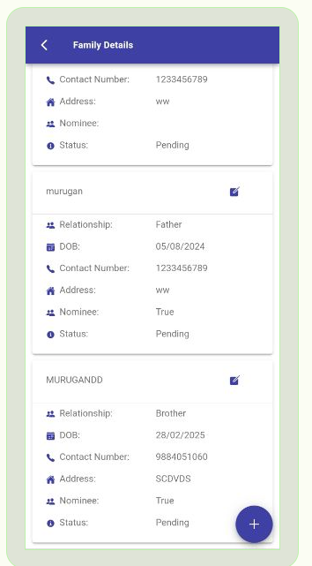

ADD function is working Fine
Update or Edit Is Working fine

https://web3essapi.elitehrms.in/api/Personal/postFamilyDetails
{"FamilyDetails":[{"FamilyID":"","RequestGUID":"df26bfe3-2ffa-804c-17fe-ae95e913766e","Name":"MURUGANDD","Relationshipid":"9800","Genderid":"9753","DOB":"2025-02-28","ContactNumber":9884051060,"Adddress":"SCDVDS","RequestStatusID":"","RelationShip":"","Gender":"","Nominee":true,"NomineePerc":"","RequestStatus":""}],"Screenid":442}

{
"Response": {
"_status": "Success",
"_code": "111",
"_Source": "postFamilyDetails",
"_Description": "Inserted Successfully...",
"_Details": "Workflow screen not added",
"_TransID": null,
"_Timestamp": "20240830153331"
},
"ScreenID": 0,
"FamilyDetails": []
}

My Profile Documents
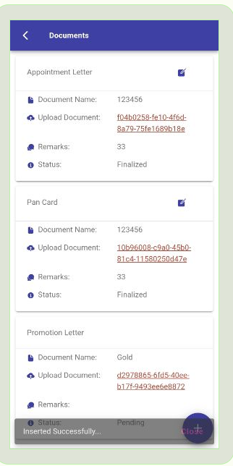
https://web3essapi.elitehrms.in/api/Personal/postFamilyDetails
{"FamilyDetails":[{"FamilyID":"","RequestGUID":"df26bfe3-2ffa-804c-17fe-ae95e913766e","Name":"MURUGANDD","Relationshipid":"9800","Genderid":"9753","DOB":"2025-02-28","ContactNumber":9884051060,"Adddress":"SCDVDS","RequestStatusID":"","RelationShip":"","Gender":"","Nominee":true,"NomineePerc":"","RequestStatus":""}],"Screenid":442}

My Profile - Employee Skils

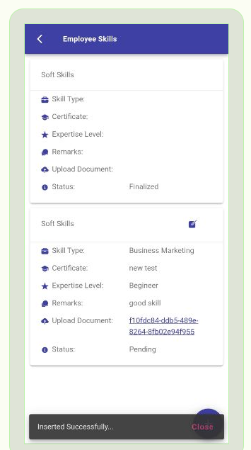

EDIT or Update
Working Fine
https://web3essapi.elitehrms.in/api/Personal/postFamilyDetails
{"FamilyDetails":[{"FamilyID":"","RequestGUID":"df26bfe3-2ffa-804c-17fe-ae95e913766e","Name":"MURUGANDD","Relationshipid":"9800","Genderid":"9753","DOB":"2025-02-28","ContactNumber":9884051060,"Adddress":"SCDVDS","RequestStatusID":"","RelationShip":"","Gender":"","Nominee":true,"NomineePerc":"","RequestStatus":""}],"Screenid":442}
{
"Response": {
"_status": "Success",
"_code": "111",
"_Source": "postFamilyDetails",
"_Description": "Inserted Successfully...",
"_Details": "Workflow screen not added",
"_TransID": null,
"_Timestamp": "20240830153331"
},
"ScreenID": 0,
"FamilyDetails": []
}

https://web3essapi.elitehrms.in/api/Personal/postSkillDetails
{"SkillDetails":[{"Skillid":"9815","SkillTypeid":"9817","Certification":"JAVA","Expertiselevelid":"9822","Remarks":"test","UploadCertificate":"","SkillGUID":"b321c0c2-b0ac-ed38-f143-b6774e3dcb27","RequestGUID":"e0ebec08-bf34-7bc2-b1d3-01979392f107"}],"Screenid":442}
{
"Response": {
"_status": "Success",
"_code": "111",
"_Source": "postSkillDetails",
"_Description": "Inserted Successfully...",
"_Details": "Workflow screen not added",
"_TransID": null,
"_Timestamp": "20240830160239"
},
"ScreenID": 0,
"SkillDetails": []
}

My Profile - Employee Asset

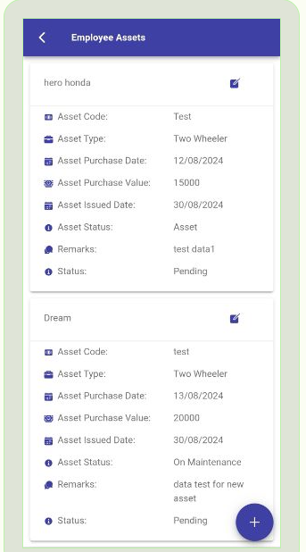

Edit or Update – Working Fine
https://web3essapi.elitehrms.in/api/Personal/postAssetDetails
{"AssetDetails":[{"AssetCode":"test","AssetName":"Dream ","AssetTypeid":"9812","AssetPurchaseDate":"2024-08-13","AssetPurchaseValue":"20000","AssetissuedDate":"2024-08-30","AssetStatusid":"9857","Remarks":"data test for new asset","RequestGUID":"69ea7cb6-198e-e8e4-0ab4-337734a5fdc8"}],"Screenid":442}

{
"Response": {
"_status": "Success",
"_code": "111",
"_Source": "postAssetDetails",
"_Description": "Inserted Successfully...",
"_Details": "Workflow screen not added",
"_TransID": null,
"_Timestamp": "20240830160532"
},
"ScreenID": 0,
"MailStatus": null,
"AssetDetails": []
}

ADD or Create - working fine
https://web3essapi.elitehrms.in/api/Personal/postAssetDetails
{"AssetDetails":[{"AssetCode":"10002","AssetName":"LAP","AssetTypeid":"9806","AssetPurchaseDate":"2024-08-01","AssetPurchaseValue":"10000","AssetissuedDate":"2024-08-29","AssetStatusid":"9854","Remarks":"test","RequestStatusID":"","RequestStatusid":"","RequestGUID":"cd13684e-516a-92b9-0834-4a1c1c7e9aaf"}],"Screenid":442}
{
"Response": {
"_status": "Success",
"_code": "111",
"_Source": "postAssetDetails",
"_Description": "Inserted Successfully...",
"_Details": "Workflow screen not added",
"_TransID": null,
"_Timestamp": "20240830160725"
},
"ScreenID": 0,
"MailStatus": null,
"AssetDetails": []
}

MY Profile - Employee Award
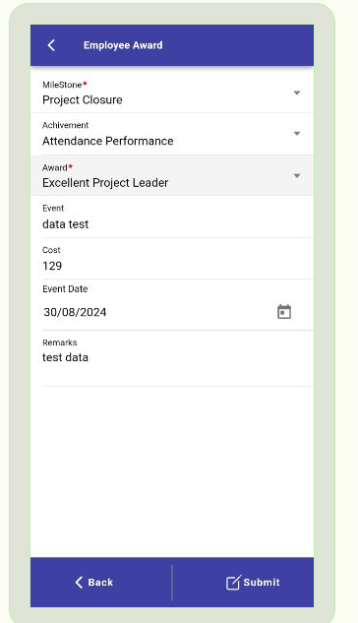
Edit or Update - Working fine
https://web3essapi.elitehrms.in/api/Personal/postAwardDetails
{"AwardDetails":[{"Achivementid":"9833","Awardid":"9836","Cost":"129","Event":"data test","EventDate":"2024-08-30","MileStoneid":"9829","Remarks":"test data","RequestStatusID":"6862","RequestStatusid":"6862","RequestGUID":"3d5ceb06-a19b-4824-b467-ef14f2c7a2f1"}],"Screenid":442}
{
"Response": {
"_status": "Success",
"_code": "111",
"_Source": "postAwardDetails",
"_Description": "Inserted Successfully...",
"_Details": "Workflow screen not added",
"_TransID": null,
"_Timestamp": "20240830160938"
},
"ScreenID": 0,
"AwardDetails": []
}
ADD or Create
https://web3essapi.elitehrms.in/api/Personal/postAwardDetails
{"AwardDetails":[{"Achivementid":"9833","Awardid":"9835","Cost":10000,"Event":"Monthly ","EventDate":"2024-08-07","MileStoneid":"9830","Remarks":"Dinakaran ","RequestStatusID":"","RequestStatusid":"","RequestGUID":"228cab35-8611-1802-5fff-6ea949c0bb26"}],"Screenid":442}

{
"Response": {
"_status": "Success",
"_code": "111",
"_Source": "postAwardDetails",
"_Description": "Inserted Successfully...",
"_Details": "Workflow screen not added",
"_TransID": null,
"_Timestamp": "20240830161144"
},
"ScreenID": 0,
"AwardDetails": []
}

My Profile - Employee VISA
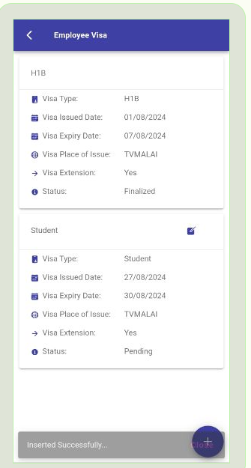

Edit or Update

https://web3essapi.elitehrms.in/api/Personal/postVisaDetails
{"VisaDetails":[{"VisaTypeid":"9782","VisaIssuedDate":"2024-08-27","VisaExpiryDate":"2024-08-30","VisaPlaceofissue":"TVMALAI","VisaExtension":true,"RequestStatusID":"6862","RequestStatusid":"6862","RequestGUID":"77d74ccb-fbc3-bdef-f6b1-71009667331e"}],"Screenid":442}

{
"Response": {
"_status": "Success",
"_code": "111",
"_Source": "postVisaDetails",
"_Description": "Inserted Successfully...",
"_Details": "Workflow screen not added",
"_TransID": null,
"_Timestamp": "20240830161422"
},
"ScreenID": 0,
"VisaDetails": []
}

ADD or Create
https://web3essapi.elitehrms.in/api/Personal/postVisaDetails
{"VisaDetails":[{"VisaTypeid":"9784","VisaIssuedDate":"2024-08-01","VisaExpiryDate":"2026-09-30","VisaPlaceofissue":"tvma","VisaExtension":true,"RequestStatusID":"","RequestStatusid":"","RequestGUID":"9df62c63-682f-12a6-567d-a7aeedd683ff"}],"Screenid":442}

{
"Response": {
"_status": "Success",
"_code": "111",
"_Source": "postVisaDetails",
"_Description": "Inserted Successfully...",
"_Details": "Workflow screen not added",
"_TransID": null,
"_Timestamp": "20240830161614"
},
"ScreenID": 0,
"VisaDetails": []
}

